Exercises: Migrations and Django Admin
Submit your solutions to the SoftUni Judge system.
Ask your questions here: https://www.slido.com by entering the course code #python-db

Shoe
Write a Django model called "Shoe" with the provided information:
- brand - character field, consisting of a maximum of 25 characters.
- size - positive integer field.
Note: Apply all the migrations to the database before executing the following steps. Also, keep in mind that the exercises with custom data migration will NOT be tested in the Judge system.

Show all the migrations
You can list the applied migrations with the command:
- "python manage.py showmigrations -l"
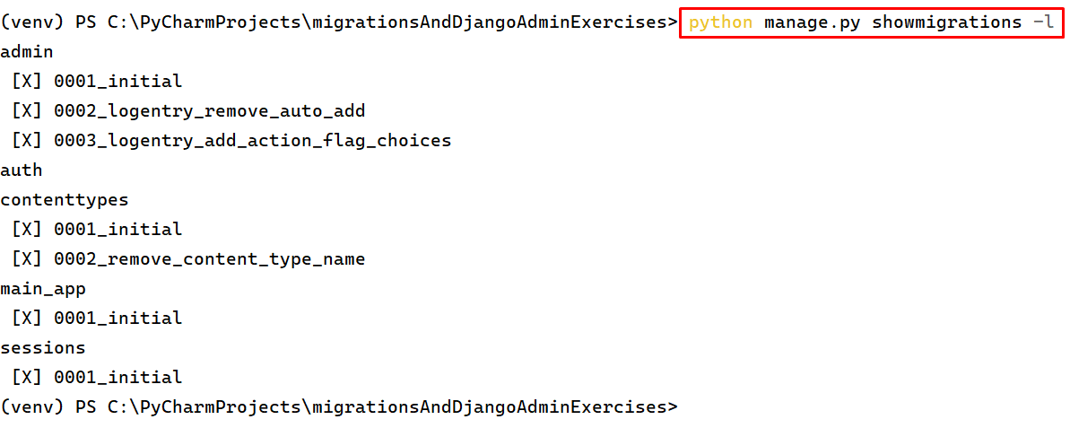
As you can see there is a result in the terminal with all the applied migrations.

SQL code through migrations
You can print the generated SQL code with the command:
- "python manage.py sqlmigrate main_app 0001_initial".
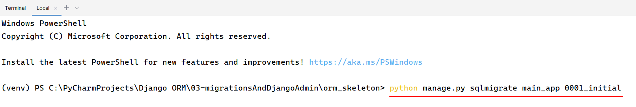

Constraints:
- main_app refers to the application name.
- 0001_initial refers to the migration name.
Create a function that migrates only the unique brands in a new model called "UniqueBrands" with the following field:
- brand_name - character field, consisting of a maximum of 25 characters, unique.

Hint:
First, create a new empty migration and name it "migrate_unique_brands". You can do it with the command:
- "python manage.py makemigrations main_app --name migrate_unique_brands --empty"
In the "0003_migrate_unique_brands.py" file create a new function and give it a name of your preference.
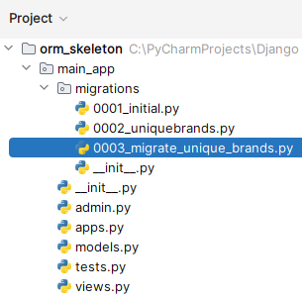
Implement the following code:
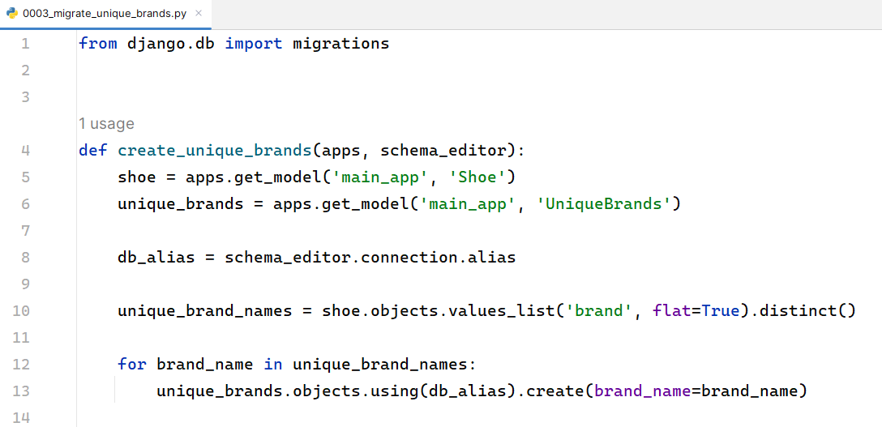
Let’s break the code step by step:
- First, we use the "apps.get_model()" method to retrieve the model classes for the "Shoe" and "UniqueBrands" models. "main_app" is the name of the app that contains these models.
- After that we take the connected database.
- Next, we fetch unique brand names from the "Shoe" model.
- Then, we use the "values_list()" method with the "flat=True" argument to get a list of unique brand names from the "Shoe" model. The "distinct()" method ensures that we only get distinct brand names.
- Finally, we iterate through the "unique_brand_names" list and use the "create()" method of the "UniqueBrands" model to create a new "UniqueBrands" object for each unique brand name. We pass the "brand_name" argument to set the value for the "brand_name" field of the "UniqueBrands" object.
We need to add the function inside the operations list:
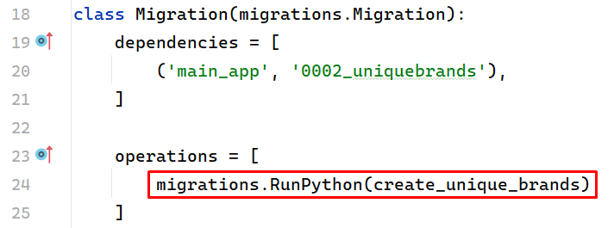
We also need to fulfill information inside the "Shoe" model table:
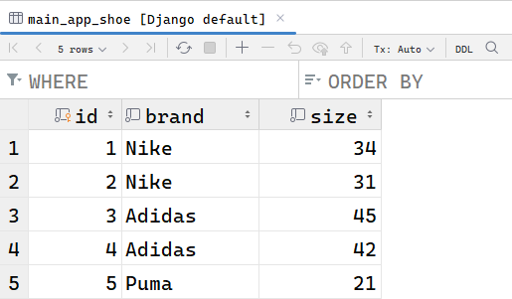
After we apply all migrations, the new table in the database will be filled with the unique data.
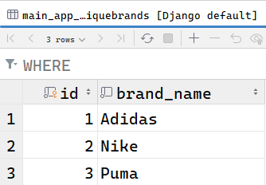

Reduce the number of migration files
You can use the following command to reduce the number of migration files by combining them into fewer files:
- "python manage.py squashmigrations main_app 0003".
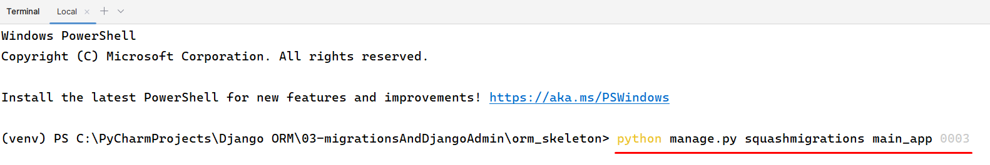

Event Registration
Write a Django model called "EventRegistration" with the provided fields:
- event_name - character field, consisting of a maximum of 60 characters.
- participant_name - character field, consisting of a maximum of 50 characters.
- registration_date - date field.

Methods

__str__()
Return the name of the participant and the name of the event as a string in the following format:
- "{participant_name} - {event_name}".

Register the model in the admin site
Create a new Django model called "EventRegistrationAdmin" in the "admin.py" file. You must register the model. It is optional to create a superuser to navigate easily through the admin site.

Customize the admin site
- The fields of the model - event_name, participant_name and registration_date should be displayed as columns.
- Filter the fields of the model by event_name and registration_date.
- Search the records of the model by event_name and participant_name.

Movie
Write a Django model called "Movie" with the provided fields:
- title - character field, consisting of a maximum of 100 characters.
- director - character field, consisting of a maximum of 100 characters.
- release_year - positive integer field.
- genre - character field, consisting of a maximum of 50 characters.

Methods

__str__()
Return the title and the director of the movie as a string in the following format:
- "Movie "{title}" by {director}".

Register the model in the admin site
Create a new Django model called "MovieAdmin" in the "admin.py" file. You must register the model.

Customize the admin site
- The fields of the model - title, director, release_year, and genre should be displayed as columns.
- Filter the fields of the model by release_year and genre.
- Search the records of the model by title and director.

Student
Write a Django model called "Student" with the provided fields:
- first_name - character field, consisting of a maximum of 50 characters.
- last_name - character field, consisting of a maximum of 50 characters.
- age - positive integer field.
- grade - character field, consisting of a maximum of 10 characters.
- date_of_birth - date field.

Methods

__str__()
Return the first name and the last name of the student as a string in the following format:
- "{first_name} {last_name}".

Register the model in the admin site
Create a new Django model called "StudentAdmin" in the "admin.py" file. You must register the model.

Customize the admin site
- Display the model fields - "first_name", "last_name", "age" and "grade" as columns.
- Filter the model fields by "age", "grade" and "date_of_birth".
- Search the model’s records by "first_name".
- Organize the fields of the model into two sections:
"Personal Information" consists of four fields - first_name, last_name, age, and date_of_birth.
"Academic Information" consists of one field - grade.

Supplier
Write a Django model called "Supplier" with the provided fields:
- name - character field, consisting of a maximum of 100 characters.
- contact_person - character field, consisting of a maximum of 50 characters.
- email - email field, unique.
- phone - character field, consisting of a maximum of 20 characters, unique.
- address - text field.

Methods

__str__()
Return the name and the phone of the supplier as a string in the following format:
- "{name} - {phone_number}".

Register the model in the admin site
Create a new Django model called "SupplierAdmin" in the "admin.py" file. You must register the model.

Customize the admin site
- The fields of the model - name, email, and phone should be displayed as columns.
- Filter the model fields by name, and phone.
- Search the model’s records by email, contact_person, and phone.
- Objects list per page - 20.
- Organize the fields of the model into one section:
"Information" consists of four fields - name, contact_person, email and address.

Course
Write a Django model called "Course" with the provided information:
- title - character field, consisting of a maximum of 90 characters.
- lecturer - character field, consisting of a maximum of 90 characters.
- description - text field, consisting of a maximum of 200 characters.
- price - decimal field, with maximum of 10 digits and 2 decimal places.
- start_date - date field. Every time a new record is created the current time of the creation of the record should be saved.
- is_published - boolean field with default value "True".

Methods

__str__()
Return the title and the lecturer of the course as a string in the following format:
- "{title} - {lecturer}".

Register the model in the admin site
Create a new Django model called "CourseAdmin" in the "admin.py" file. You must register the model.

Customize the admin site
- Display the model fields - title, lecturer, price, and start_date as columns.
- Filter the model fields by is_published, and lecturer.
- Search the model’s records by title and lecturer.
- Read-only fields - start_date.
- Organize the fields of the model into two sections:
"Course Information" consists of five fields - title, lecturer, price, start_date, and is_published.
"Description" consists of only one field - description.

Person
Write a Django model called "Person" with the provided information:
- name - character field, consisting of a maximum of 40 characters.
- age - positive integer field.
- age_group - character field, consisting of a maximum of 20 characters, with a default value of "No age group".

Methods

__str__()
Return the name as a string in the following format:
- "Name: {name}".

Functions inside the migration files
Create a new function that migrates information for the age group for every person based on their age.
- If the age is less than or equal to 12 - set the group to "Child".
- If the age is between 13 and 17 (both inclusive) - set the group to "Teen".
- If the age is greater than or equal to 18 - set the group to "Adult".

Item
Write a Django model called "Item" with the provided information:
- name - character field, consisting of a maximum of 100 characters.
- price - decimal field, with a maximum of 10 digits, 2 decimal places.
- quantity - positive integer field, with a default value of 1.
- rarity - character field, consisting of a maximum of 20 characters, with a default value of "No rarity".

Functions inside the migration files
Create a new function that applies a new value to the rarity of the item based on the price of the item.
- If the price is less than or equal to 10 - the rarity is "Rare".
- If the price is between 11 and 20 (both inclusive) - the rarity is "Very Rare".
- If the price is between 21 and 30 (both inclusive) - the rarity is "Extremely Rare".
- If the price is greater than or equal to 31 - the rarity is "Mega Rare".

Smartphone
Write a Django model called "Smartphone" with the provided information:
- brand - character field, consisting of a maximum of 100 characters.
- price - decimal field, with a maximum of 10 digits, 2 decimal places, and a default value of 0 (zero).
- category - character field, consisting of a maximum of 20 characters, with default value "No category".

Functions inside the migration files
Create two functions that set new values for the price and the category fields:
- The first function generates a new price based on the brand's length multiplied by 120. Ensure that you've applied the required migrations before proceeding to create the next function.
- The second one generates a new value - "Expensive" to the category field only if the price is greater than or equal to 750. Otherwise, the new value should be "Cheap".

10. Order [Solve with AI]
Write a Django model called "Order" with the provided information:
- product_name - character field, consisting of a maximum of 30 characters.
- customer_name - character field, consisting of a maximum of 100 characters.
- order_date - date field.
- status - character field, consisting of a maximum of 30 characters with choices - "Pending", Completed", or "Cancelled".
- amount - positive integer field with default value 1.
- product_price - decimal field with a maximum of 10 digits and 2 decimal places.
- total_price - decimal field with a maximum of 10 digits, 2 decimal places, with a default value of 0 (zero).
- warranty - character field, with a default value of "No warranty".
- delivery - date field, optional.

Functions inside the migration files
Create a function that modifies the delivery and warranty of all orders based on their status:
- If the order status is "Pending" the delivery is 3 days after the order date.
- If the order status is "Completed" the warranty should change to "24 months".
- If the order status is "Cancelled" remove the order from the database.

